# Authentication and Security 1. register, login, email authentication, set and reset password functions. 2. controlled by a single PHP session variable RegState

**Steps to involve to make the page :**

* Build a MySQL table (what data to collect?): Users(ID, **Email**, **Password**, Acode, Adatetime, Rdatetime, Status, FirstName, LastName)
* Build a login view in index.php using Bootstrap 4.0.
* Revise index.php to include more dynamic views for a) Registration, b) Set password, and c) Reset password.
* Build login.php, register2.php, authenticate.php, setPassword.php and resetPassword2.php.
* Once the user login, your project page should be openned freely. Otherwise, your project page should remain sealed.
* Build the project page.
* Test and debug the project page.
* Integrate with the login page, test and hand in.

**The “RegState” Robot**

* Status = 0 initial state.
* Status = 1 when the user clicked on “register”.
* Status = 2 when registration succeeds and email sent.
* Status = 3 when email and acode authentication succeeds. Allowed for password setup.
* Status = 4 when the use logged in.
* Status = 6 “reset password” clicked.
* Status < 0 Errors.

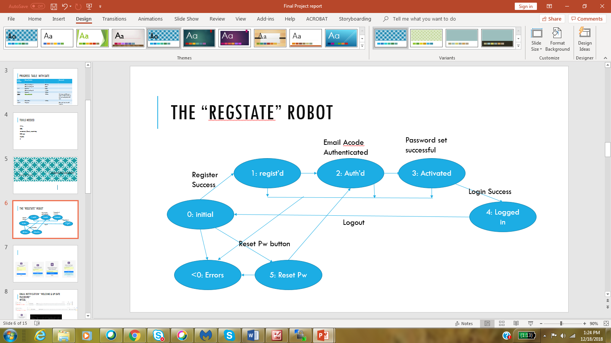

Set password & update password

* Single HTML script with multiple views controlled by session variable.
* Build login.php using Bootstrap
* Add registration form.
* Add setPassword form.
* Add resetPassword form.
* Initiate PHP <?php session_start(); ?>
* Control the form display using the values of $_SESSION[“RegState”]

Email Authentication

The new OS and SMTP security rules prohibit ad hoc email server as senders in order to control spam.

A private Gmail account was registered for classes.

